47th National Chemistry Olympiad

Utrecht University

THEORY TEST

Question booklet


Monday 8th June 2026





- This test consists of 7 problems with 35 open questions.
- Use a separate answer sheet for each problem, making sure to write your name on each sheet. Maintain a 2 cm margin on all sides of the page.
- The maximum score for this test is 120 points.
- The test will last a maximum of 4 hours.
- Required resources: (graphic) calculator and Binas 7th edition or BINAS 5th edition, English version or ScienceData 1st edition.
- The number of points available for each question is given.
- Unless otherwise stated, standard conditions apply: T = 298 K and p = p₀.

This test was made possible with the support of the following people:
Danny Broere
Wouter Elings
Ben Erne
Eline Hutter
Willem Kegel
Merel Lefferts
Andries Meijerink
Marc-Etienne Moret
Freddy Rabouw
Joost Snijder
The final editing was done by:
Kees Beers, Martin Groeneveld and Dick Hennink
The test was translated into English by:
Guus Bukkems and Anna Reinhold

The translation of the test was checked by:
Jan Rombach en Lauren Rutherford
The NSO committee
Marijn Jonker and Emiel de Kleijn

- Trouble in a cylinder 10 points
A cylinder sealed by a movable piston contains a quantity of propane. The cylinder is heated to 527 ºC. The following equilibrium is established:
C₃H₈(g) C₃H₆(g) + H₂(g) with K_{c} = 1,30·10⁻³
When equilibrium has been reached, the volume percentage of propane is equal to 80%.
- Calculate [C₃H₈], [C₃H₆], [H₂], all in mol dm⁻³, and the total pressure, in Pa, in the cylinder
when equilibrium has been reached. 7
Next, the piston is pushed in until the volume is reduced by half while maintaining a constant temperature.
- Once equilibrium has been re-established, will the pressure in the cylinder be twice as high, more than twice as high, or less than twice as high? Explain your answer. 3

- Malaprade 19 points
Organic compounds with certain functional groups in the molecule that are bonded to neighboring (vicinal) carbon atoms can react with sodium periodate (NaIO₄). In this reaction, the bond between the carbon atoms to which the functional groups are attached is broken, while the groups bound to those carbon atoms are also transformed. The following rules apply:
- When the functional group is a hydroxyl group, it is converted into a carbonyl group.
- When the functional group is a carbonyl group, it is converted into a carboxyl group.
- When the functional group is a carboxyl group, it is converted into carbon dioxide.
This reaction may be referred to as the Malaprade reaction. The Malaprade reaction is a redox reaction.
For example: 2-hydroxy-2-methylpropanal is converted by periodate into methanoic acid and propanone in a molar ratio 1 : 1; the periodate is converted into iodate (IO₃⁻):
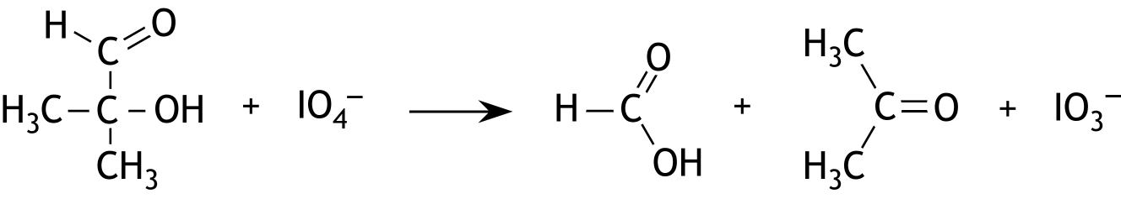

- Give the structural formula of the compound that yields ethanoic acid as the sole product in the Malaprade reaction. 2
The Malaprade reaction can be used, among others, to determine the concentration of glycol (ethane-1,2-diol) in solution. A glycol solution is commonly used as antifreeze.
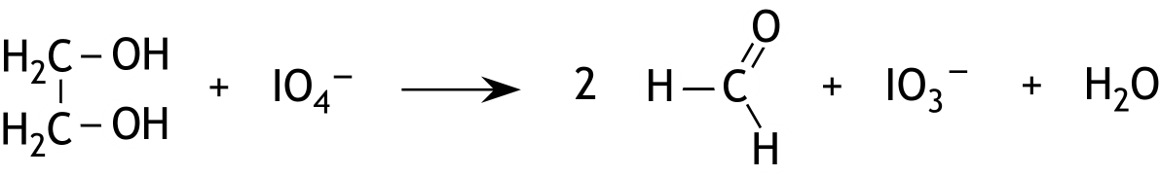
In such a determination, 150 mg of antifreeze was added to a 25.0 mL solution of sodium periodate (in excess). The following reaction occurred:

After the reaction was complete, the solution was acidified and an excess amount of iodide was added. Both the IO₄⁻ and the formed IO₃⁻ reacted with iodide to form I₂:
IO₄⁻ + 7 I⁻ + 8 H⁺ → 4 I₂ + 4 H₂O
and
IO₃⁻ + 5 I⁻ + 6 H⁺ → 3 I₂ + 3 H₂O
Finally, the formed iodine was titrated with a 0.502 M solution of sodium thiosulfate. The following reaction occurred:
I₂ + 2 S₂O₃²⁻ → 2 I⁻ + S₄O₆²⁻
The titration required 19.6 mL of the sodium thiosulfate solution.
Next, a blank determination was performed, as described above, but without adding the antifreeze. For this blank determination, 23.9 mL of the sodium thiosulfate solution was required to titrate the formed iodine.
- Calculate the mass percentage of glycol in the antifreeze sample. 8
The Malaprade reaction can also be used to distinguish between certain sugars. For example the Malaprade reaction can be used to determine whether a sugar is glucose or fructose.
During the Malaprade reaction with glucose and fructose, all C − C bonds in the molecules are broken. The following substances can then be formed: methanal, methanoic acid and carbon dioxide.
- Answer the following questions: 9
- Which substances are finally formed in the Malaprade reaction of glucose, and in what molar ratio are these substances formed?
- Which substances are finally formed in the Malaprade reaction of fructose, and in what molar ratio are these substances formed?
- How could you determine whether a sugar is glucose or fructose: by determining the molar ratio in which glucose and fructose react with periodate, or by titrating the reaction products of the Malaprade reaction with sodium hydroxide? Explain your answer.
Use the information provided at the beginning of this problem and the open-chain structures of glucose and fructose:
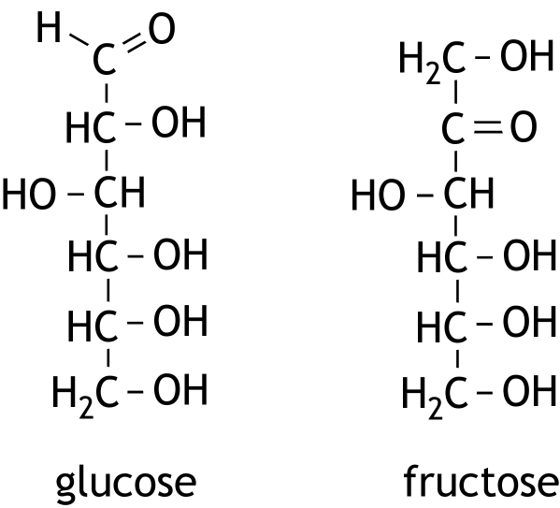

- Electrochemical conversion of CO₂ 23 points
The electrochemical conversion of CO₂ is seen as a promising and technically feasible method for mitigating the negative effects of rising CO₂ levels in the atmosphere.
Using renewable energy, CO₂ can be converted into various platform chemicals.
To ensure that the formation of desired products during electrolysis proceeds at a practically feasible rate, research is conducted into the use of electrocatalysts.
A new concept in the field of such catalysts is based on the use of electrodes coated in a foam-like material.
This foam-like material has a large surface area that is readily accessible to reactants (e.g H₂O, H₂ en CO₂).
Copper-based materials are the only known metallic electrocatalysts capable of producing hydrocarbons and alcohols in significant quantities through the electrolysis of CO₂.
During a specific electrolysis in an acidic medium, CO₂ is converted at the negative electrode into ethanol and propan-1-ol. In these conversions, 6 moles of electrons react per mole of converted CO₂.
- Provide the equation of the half-reaction for the conversion of CO₂ to propan-1-ol in an acidic medium. 3

The standard electrode potential for the conversion of CO₂ to ethanol can be calculated by considering a galvanic cell consisting of a standard CO₂/ethanol half-cell and a standard H₂/H⁺ half-cell.
The reaction occurring in this galvanic cell can be represented by the following reaction equation:

2 CO₂(g) + 6 H₂(g) → C₂H₆O(l) + 3 H₂O(l)
- Calculate the standard electrode potential for the conversion of CO₂ to ethanol. Use data from the information booklet and the formula Δ_{r}G = − n × F × ΔE. 5

A representative example of the formation of electrode material with a copper-based metallic foam layer is described below:
Electrolysis is carried out in an acidic solution containing both copper(II) ions and silver ions. A copper plate with a surface area of 1.0 cm² serves as the negative electrode, while platinum foil acts as the positive electrode. During electrolysis, a layer of porous, foam-like Cu-Ag bimetal deposits on the negative electrode. This porous structure of the bimetal forms because tiny hydrogen bubbles evolve within the bimetal during the metal deposition. The bimetal is, so to speak, slightly inflated.
A layer of foam containing 5.4 mg of Cu-Ag bimetal forms on the copper plate.
This bimetal contains 90% Cu by mass and 10% Ag.
During this electrolysis 60 C cm⁻² of charge was used.
- Calculate the Faraday efficiency (FE in %) of this metal deposition.
FE is defined as . Q represents the amount of electric charge. 4

The Cu-Ag bimetallic foam catalyst (90 wt% Cu; 10 wt% Ag) is used in a CO₂ electrolysis experiment:
35 mL of 0.5 M KHCO₃ electrolyte solution saturated with CO₂ is electrolyzed.
The negative copper electrode is coated with the Cu-Ag bimetallic foam catalyst and the positive electrode is made of platinum. The CO₂ electrolysis is carried out at a constant current density of J = 30 mA cm⁻² for 1.0 hour (Note: the current density is normalized to a surface area of 1.0 cm²).
An analysis of the product after the electrolysis yields mass concentrations of 41.3 mg L⁻¹ ethanol and 7.4 mg L⁻¹ propan-1-ol. Both alcohols are liquid reaction products and accumulate in the electrolyte during the electrolysis. It may be assumed that only hydrogen gas (H₂) is formed as a byproduct at the negative electrode.
- Provide the equation for the half-reaction that occurs at the positive electrode. 2

In the electrolysis described above, 33.6 percent of the current is used for the production of ethanol and 6.9 percent for the production of propan-1-ol.
- Calculate how many cm³ H₂ (at p₀ and 298 K) is formed at the negative electrode. 5
- Calculate how many mg of CO₂ are converted in the electrolysis described above.
Assume that the total volume of the electrolyte, ethanol, and propan-1-ol remains 35 mL. 4
- Crotonic acid 17 points
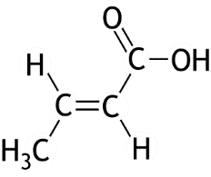
Crotonic acid has the following chemical structure:

- Copy this structural formula onto your answer sheet and write the type of hybridization for each carbon atom. 2

There are various synthetic routes for the production of crotonic acid. The byproducts often include the stereoisomer and a specific structural isomer A of crotonic acid. The mass spectra of crotonic acid and of this structural isomer A are shown below.
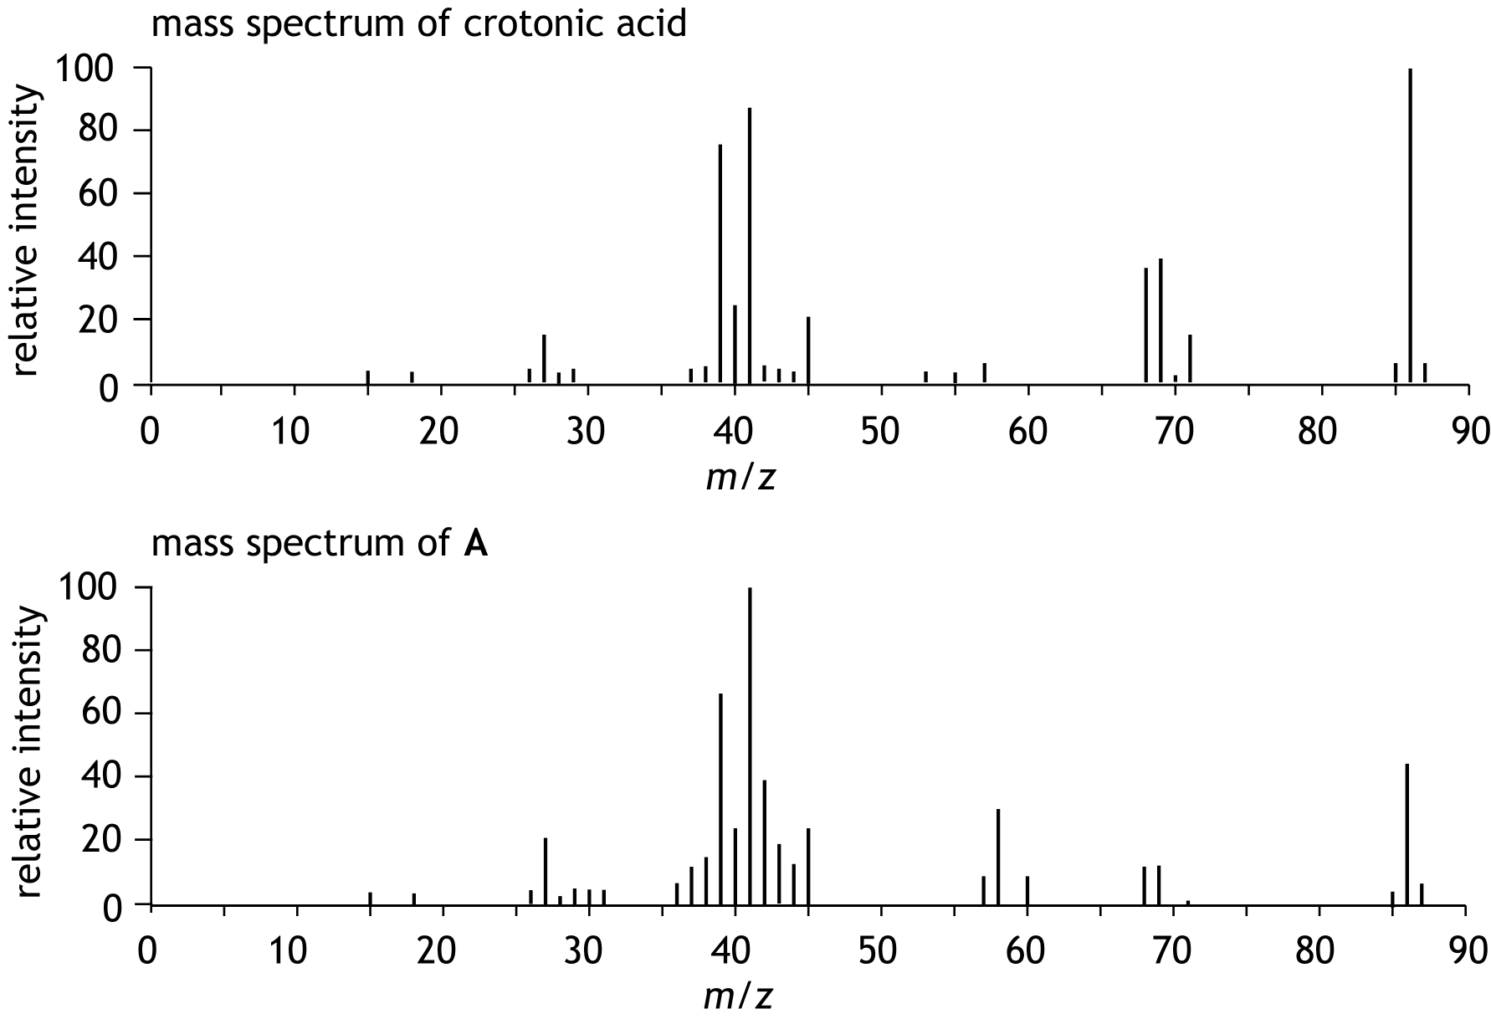

- Perform the following tasks:
- Explain, based on these mass spectra, that A is a structural isomer of crotonic acid.
- Explain that it can be deduced from these mass spectra that A, like crotonic acid, is
also a carboxylic acid. 3

Crotonic acid can be obtained by the thermolysis of the biopolymer
poly(3-hydroxybutanoic acid). This polymer can be produced by certain bacteria.
- Provide the structural formula of a fragment from the middle of a molecule of this polymer. This fragment must consist of three monomer units. 3
- Provide the reaction equation in molecular formulas for the thermolysis of poly(3-hydroxybutanoic acid) to crotonic acid. 2

Crotonic acid is used as a starting material in organic synthesis.
A specific synthetic route starts with the electrophilic addition of bromine to crotonic acid. This reaction yields 2,3-dibromobutanoic acid.
This addition reaction proceeds via a so-called anti-mechanism:
A bromine molecule reacts with a crotonic acid molecule. This produces a so-called bromonium ion and a bromide ion. In the bromonium ion, Br is located at the bottom or at the top of the ion. The bromide ion then reacts from the opposite side (anti), forming the product. This can result in the following product:
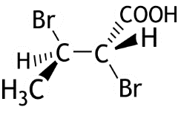

- Explain whether carbon atom 2 has the R or the S configuration. Include a drawing in your explanation. 3
In the structural formula shown for 2,3-dibromobutanoic acid, various stereoisomers are possible. However, not all of these are formed during the electrophilic addition of bromine to crotonic acid.
- Explain how many stereoisomers of 2,3-dibromobutanoic acid are possible in total,
in principle. 2
- Explain how many stereoisomers of 2,3-dibromobutanoic acid are formed during the electrophilic addition of bromine to crotonic acid. 2

- CoFe 17 points
The structure of the chloropentaamminecobalt(III) complex, Co(Cl)(NH₃)₅²⁺, is shown below.
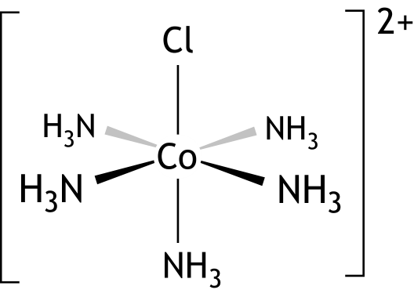

These complexes occur in a solution of chloropentaamminecobalt(III) chloride. An excess of a silver nitrate solution is added to 10.00 mL of a 0.0500 M solution of chloropentaamminecobalt(III) chloride. This produces a precipitate.
- Calculate how many g of precipitate are formed. 3

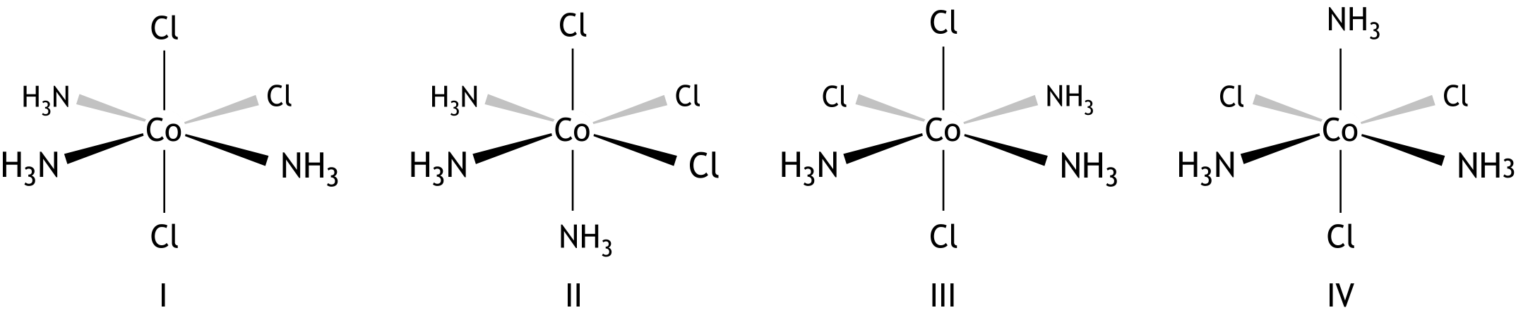
Co(Cl)₃(NH₃)₃ complexes also exist. Four structures with this formula are shown below:

- Which of these structures are identical? 2

A solution that contains complex ions Co(Cl)(NH₃)₅²⁺ is red in colour. The transmittance, T, of a solution with [Co(Cl)(NH₃)₅²⁺] = 0.0200 mol L⁻¹ is measured at 520 nm in a cuvette with a path length of 1.00 cm. The transmittance is 7.50%.
- Calculate the molar extinction coefficient ε of Co(Cl)(NH₃)₅²⁺. Assume that in this solution, only Co(Cl)(NH₃)₅²⁺ absorbs light. 3

When an acidified solution of iron(II) chloride is added to a solution containing Co(Cl)(NH₃)₅²⁺, the following reaction takes place:
Co(Cl)(NH₃)₅²⁺ + Fe²⁺ + 5 H⁺ → Co²⁺ + FeCl²⁺ + 5 NH₄⁺
The speed of this reaction is given by r = k[Co(Cl)(NH₃)₅²⁺][Fe²⁺].
To determine the rate constant k of this reaction, an experiment is carried out in which 10.00 mL of a 0.300 M solution of iron(II) chloride is added to 10.00 mL of a solution containing Co(Cl)(NH₃)₅²⁺. Care is taken to ensure that the initial concentration of Fe²⁺ is many times greater than the concentration of Co(Cl)(NH₃)₅²⁺.
During the reaction, the absorbance A of the solution is measured at 520 nm at various points in time. The following observations are obtained:
t (min) | 10 | 20 | 40 | 60
A | 1.15 | 0.875 | 0.558 | 0.410 | 0.283
The absorbance at t = is the absorbance measured once the reaction has finished.
For the calculation of k, you can assume that [Co(Cl)(NH₃)₅²⁺]_{t} is proportional to (E_{t} − ).
- Give a possible explanation for the fact that does not equal zero. 1
- Explain why [Co(Cl)(NH₃)₅²⁺]_{t} is proportional to (E_{t} − ). 2
- Calculate k in the correct SI unit. 6

- Dipeptide 14 points

Dipeptides are an important source of nitrogen and free amino acids within the cell. It turns out that transport of dipeptides across the cell membrane via specialised transport proteins is faster and, moreover, more energy-efficient than the transport of free amino acids. As a result, the cell efficiently takes in twice the amount of building blocks.

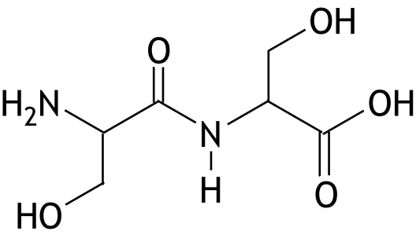
The dipeptide Ser − Ser dissolves easily in water; the structural formula for Ser − Ser can be represented as follows:

In a neutral solution, Ser − Ser is rarely found in the form shown in the structural formula above.
- Show, using a structural formula, how the dipeptide Ser − Ser mainly exists in a solution
with a pH of 7.0. 1
A Ser − Ser molecule contains what is known as an amide group. The bond between the carbon atom and the nitrogen atom in this group behaves partly like a double bond.
- Explain this using electron configurations (resonance structures) of the amide group. 3

This also means that the bonds around the nitrogen atom lie in one plane and that Ser − Ser has E/Z isomers. It turns out that one of the E/Z isomers of Ser − Ser occurs much more frequently than the other one.
- Carry out the following tasks:
- Explain that Ser − Ser has E/Z isomers.
- Draw a three-dimensional structure of the E/Z isomer of Ser − Ser that occurs most frequently and explain why it occurs most frequently. 3

The formation of the dipeptide Ser − Ser is an equilibrium reaction:
2 Ser Ser − Ser + H₂O equilibrium 1
For equilibrium 1, ∆G₁⁰ = + 1.7·10⁴ J mol⁻¹.
In biological systems, the formation of dipeptides is linked to the hydrolysis of adenosine triphosphate (ATP), which produces adenosine diphosphate (ADP) and a phosphate group (P_{i}):
ATP + H₂O ADP + P_{i} equilibrium 2
Possible formulas for P_{i} are H₃PO₄, H₂PO₄⁻, HPO₄²⁻ and PO₄³⁻.
- Which two of the options for P_{i} mentioned above are most common in a solution with a pH of 7.0? 2
For equilibrium 2, ∆G₂⁰ = − 2.8·10⁴ J mol⁻¹.
Coupling equilibrium 2 with equilibrium 1 creates a new equilibrium:

2 Ser + ATP Ser − Ser + ADP + P_{i} equilibrium 3
- Carry out the following tasks:
- Calculate the equilibrium constant K_{c,1} for equilibrium 1.
- Calculate the equilibrium constant K_{c,3} for equilibrium 3.
- Explain how the coupling of the two equilibria affects the yield of the dipeptide. 5
- Hydrogen Storage 20 points
The alloy with the formula LaNi₅ is very suitable for the storage and transport of hydrogen.
The alloy can be prepared by allowing lanthanum(III) oxide and nickel(II) oxide to react in the correct ratio in the presence of an excess of calcium hydride. This also produces calcium hydroxide. Approximately twice as much calcium hydride is used as is theoretically required.
- Calculate the mass ratio in which lanthanum(III) oxide and nickel(II) oxide must react.
Write your answer as lanthanum(III) oxide : nickel(II) oxide = … : 1.0. 3
- Calculate how many grams of calcium hydride are used to synthesise 1.0 g of LaNi₅ if a twofold excess of calcium hydride is applied. 4

Once the reaction is complete, a mixture of the solids LaNi₅, calcium hydroxide and calcium hydride is obtained. The calcium hydroxide and calcium hydride have to be removed from this mixture.
- Explain how you could do this. 2
The unit cell of LaNi₅ has the following shape:
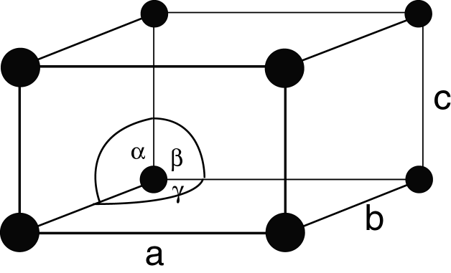

Here, the angles α and β equal 90º and the angle γ equals 120º, whilst the edges are given by a = b = 511 pm and c = 397 pm.

The formula of the unit cell is LaNi₅. The lanthanum atoms (the black dots) are located at the corners. In the full drawing of the unit cell of LaNi₅, 9 nickel atoms still have to be drawn.
- Explain where the nickel atoms can be located within the unit cell. 3
- Calculate the density of LaNi₅ in kg m⁻³. For this calculation, you will need the volume of
the unit cell; if you are unable to calculate this, assume V_{cel} = 1.2·10⁻²⁸ m³; this is not the correct volume. 3
Hydrogen atoms can occupy the spaces between the atoms in the LaNi₅ lattice. When all these spaces are filled with hydrogen atoms, the LaNi₅ alloy can hold 1 244 times as many hydrogen atoms per cm³ as are present in one cm³ of gaseous hydrogen at 273 K and p = p₀.
- Calculate the maximum number of hydrogen atoms that can be stored in one unit cell. For this calculation, you will need the volume of the unit cell; if you are unable to calculate this, assume V_{cel} = 1.2·10⁻²⁸ m³; this is not the correct volume. 5

